'''

In a mango farm, you have two rows of mango trees. Each row represents

an integer array, namely "fruitcount1" and "fruitcount2,"

sorted in ascending order to indicate the number of mangoes on each tree.

Your task is to find the trees having same count of trees in fruitcount1[],

fruitcount2[] and the fruits count is least.

If there are no such common trees, return -1.

Input Format:

-------------------

Line-1: Two space separated integers, M and N

Line-2: M space separated integers, fruitcount1[]

Line-3: N space separated integers, fruitcount2[]

Output Format:

-------------------

Print an integer result.

Sample Input:

--------------

5 4

2 4 5 8 12

3 4 6 8

Sample Output:

---------------

4

Sample Input:

--------------

5 6

2 4 5 8 12

1 3 6 8 10 12

Sample Output:

--------------

8

Write your python code below.

'''

My soln

n1,n2=map(int,input().split())

l1=list(map(int,input().split()))

l2=list(map(int,input().split()))

def fun(l1,l2):

for i in l1:

l=0

u=len(l2)-1

while(l<=u):

mid=int(l+(u-l)/2)

if(l2[mid]==i):

return i

break;

elif(l2[mid]>i):

u=mid-1

else:

l=mid+1

return -1

print(fun(l1,l2))

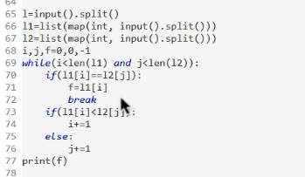

Vishal has given a task to find the successor of a given alphabet 'alp'

in a given string str[]. The alphabets in the given string str[] are

all lowercase letters and always in non-decreasing order.

A successor of 'alp' is the next smallest alphabet exist in the string str[],

which is greater than 'alp'. Assume that alphabets can be considered in

cyclic fashion. For example: Successor for alp='z' in str[]="bcd" is 'b'.

Help Vishal to return the answer.

Can you solve it in O(log(n)) complexity?

Input Format:

-------------

Line-1:A string str[]

Line-2: a character represents an alphabet.

Output Format:

--------------

Print a character which is the successor.

Constraints:

2 <= str.length<= 10^4

'alp' is a lowercase letter.

Sample Input-1:

---------------

adghijl

f

Sample Output-1:

----------------

g

Sample Input-2:

---------------

abcdefghi

j

Sample Output-2:

----------------

A

My soln:

import java.util.\*;

public class Main{

public static void main(String[] args){

Scanner sc=new Scanner(System.in);

String s=sc.next();

char c=sc.next().charAt(0);

System.out.println(fun(s,c));

}

public static char fun(String s,char c){

// boolean ans=true;

int mid=0;

int l=0;

int u=s.length()-1;

char cc='0';

while(l<=u){

mid=l+(u-l)/2;

if(s.charAt(mid)<=c){

l=mid+1;

}

else{

cc=s.charAt(mid);

u=mid-1;

}

}

if(cc!='0'){

return cc;

}

// System.out.println(cc);

return s.charAt(0);

}

}

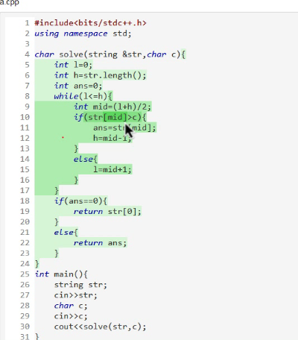

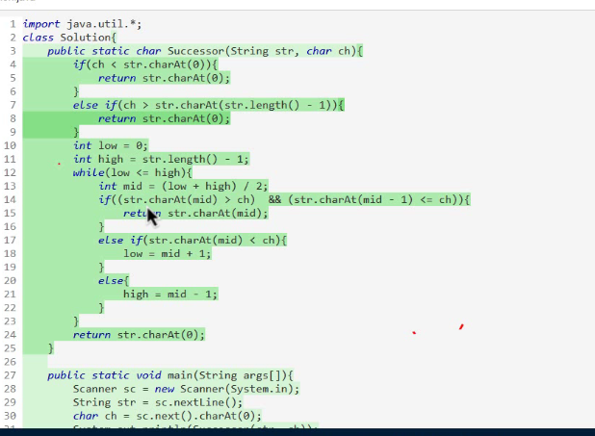

Ram and Bheem, Playing a game.

Games rules are as followed:

1- Ram picks a number P between 1 to N.

2- Bheem has to guess a number K between 1 to N

3- Ram has to say whether it is greaterthan OR lesserthan OR equal to P.

4- Repeat the rules 2 and 3, till Bheem guess the correct number.

Your task is to help Bheem to guess P correctly,

by implementing the method below in class Solution:

- int bheemsGuess(int N): return an integer, (P value)

NOTE: Can you get the solution (logN) time

INPUT FORMAT:

-------------

Two space separated integers, N and P

OUTPUT FORMAT:

--------------

Print the value of P.

SAMPLE INPUT-1:

---------------

21 18

SAMPLE OUTPUT-1:

----------------

18

SAMPLE INPUT-2:

---------------

21 3

SAMPLE OUTPUT-2:

----------------

3

